Foodborne disease surveillance and outbreak investigations in Western Australia 2016 annual report



**Enhancing foodborne disease surveillance across Australia**



OzFoodNet, Communicable Disease Control Directorate

**Acknowledgments**

Acknowledgement is given to the following people for their assistance with the activities described in this report: Mr Damien Bradford, Ms Lyn O’Reilly, Dr Niki Foster, Ms Jenny Green, and the staff from the enteric, PCR and food laboratories at PathWest Laboratory Medicine WA; Mr Stan Goodchild, Mr John Coles and other staff from the Food Unit of the Department of Health, Western Australia; Public Health Nurses from the metropolitan and regional Population Health Units; and Local Government Environmental Health Officers.

**Contributors/Editors**

Barry Combs, Niki Foster, Nevada Pingault

Communicable Disease Control Directorate

Department of Health, Western Australia

PO Box 8172

Perth Business Centre

Western Australia 6849

Email: [OzfoodnetWA@health.wa.gov.au](mailto:OzfoodnetWA@health.wa.gov.au)

Telephone: (08) 9388 4999

Facsimile: (08) 9388 4877

Web:

OzFoodNet WA Health [www.public.health.wa.gov.au/3/605/2/ozfoodnet_enteric_infections_reports.pm](http://www.public.health.wa.gov.au/3/605/2/ozfoodnet_enteric_infections_reports.pm)

OzFoodNet Department of Health and Ageing

[www.ozfoodnet.gov.au/](http://www.ozfoodnet.gov.au/)

**Disclaimer**:

Every endeavour has been made to ensure that the information provided in this document was accurate at the time of writing. However, infectious disease notification data are continuously updated and subject to change.

PUBLISHED BY

This publication has been produced by the **Department of Health, Western Australia**.

# Executive summary

This report is a summary of enteric disease surveillance activities and outbreak investigations in Western Australia (WA) in 2016.

Enteric disease causes a large burden of illness in the WA community. In WA, there are 16 enteric infections that are notifiable to the Department of Health. The Department of Health through OzFoodNet (OFN) and other agencies conducts surveillance and investigates outbreaks so that targeted interventions can be used to help prevent further transmission.

In 2016, there were 6002 notifications of enteric disease in WA, which was a rate of 226 per 100 000 population, which was 26% higher than the mean rate for the previous five years. The age group with the highest enteric disease rate was the <1 - 4 years with 535 cases per 100 000 population. The rate of enteric disease in Aboriginal people was 14% higher than non-Aboriginal people. Of the notified enteric infections with a known place of acquisition, 72% reported acquiring their infection in WA, 27% reported overseas travel and 1% reported interstate travel. Of enteric notifications reporting overseas travel, 59% had travelled to Indonesia.

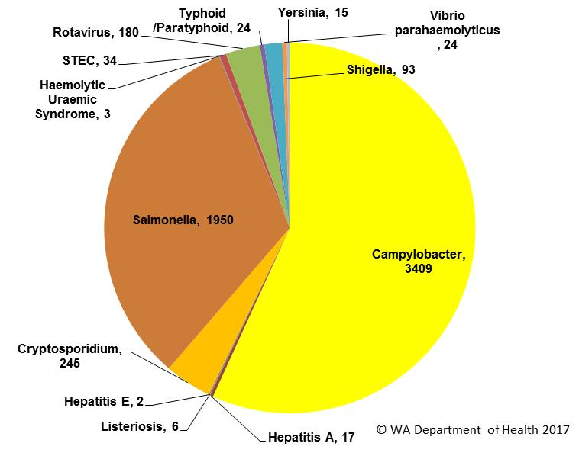

Figure A: WA enteric diseases for 2016 by disease; number of notifications

Campylobacteriosiswas the most (n=3409) commonly notified enteric disease in 2016 followed by salmonellosis (n=1950) (Figure A), which respectively had rates 34% and 36% higher than the previous five years. Cryptosporidiosis (n=245) and rotavirus (n=180) had lower rates compared to the previous five years.

**Foodborne and probable foodborne outbreaks**

In 2016, there were 21 outbreaks of foodborne or probable foodborne disease investigated in WA that caused at least 185 cases of illness (Figure B). Sixteen of these outbreaks were caused by *Salmonella* Typhimurium, two outbreaks caused by *Clostridium perfringens* and one outbreak each was caused by *Campylobacter*, *Salmonella* Enteritidis and *Vibrio parahaemolyticus*.

Of the 21 outbreaks, there were 18 outbreaks where a food was implicated and eating egg dishes was the most (n=14, 78%) implicated food.

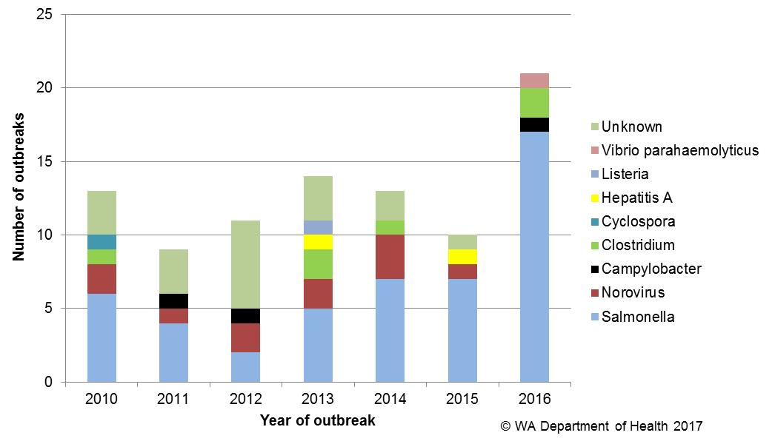

Figure B: Foodborne outbreaks investigated in WA by causative pathogen

**Non foodborne enteric disease outbreaks**

Non-foodborne enteric disease outbreaks and outbreaks with unknown mode of transmission are a major cause of illness, especially in institutions such as residential care facilities (RCF). There were 163 non-foodborne outbreaks reported in 2016 which resulted in 4214 ill people, 67 hospitalisations and 13 associated deaths. Most of these outbreaks were in RCF and due to person-to-person transmission.

**Table of contents**

Executive summary 3

1. Introduction 7

2. Data sources and methods 9

2.1. Data sources……………………………………………………………………………9

2.2. Data collection by Aboriginality…………………………………………………… 10

2.3. Regional boundaries………………………………………………………………. 10

2.4. Calculation of rates…………………………………………………………………. 10

2.5. Definitions…………………………………………………………………………… 10

3. Site activities including prevention measures during the year 11

3.1. Surveillance and investigation………………………………………………………11

3.2. Activities on enhancing laboratory and epidemiological surveillance………….11

3.3. Activities to assist enteric disease policy development………………………….12

3.4. Strengthening skills and capacity for enteric disease surveillance and investigation ………………………………………………………………………………………….12

3.5. Conference meetings and presentations ………………………………………….13

4. Incidence of specific enteric diseases 13

4.1. Campylobacteriosis 14

4.2. Salmonellosis 16

4.3. Cryptosporidiosis 19

4.4. Rotavirus infection 21

4.5. Shigellosis infection 23

4.6. Hepatitis A 26

4.7. Shiga toxin producing *E. coli* 26

4.8. Typhoid and paratyphoid fever 27

4.9. Listeriosis 27

4.10.*Vibrio parahaemolyticus* infection 28

4.11.*Yersinia* infection 28

4.12.Haemolytic Uraemic Syndrome (HUS) 28

4.13.Hepatitis E 29

4.14.Cholera and Botulism 29

5. Gastrointestinal disease outbreaks and investigations 29

5.1. Foodborne and probable foodborne outbreaks 29

5.2. Outbreaks due to non-foodborne transmission or with an unknown mode of transmission 34

5.3. Cluster investigations 36

6. References 39

Appendix 1: Number of notifications, notification rate and ratio of current to historical mean by pathogen/condition, 2011 to 2016, WA 49

List of tables

Table 1. Number and proportion of the top 10 *Salmonella* serotypes notified in WA, 2016, with comparison to the 5-year average 19

Table 2 Foodborne and probable foodborne outbreaks, 2016 33

Table 3. Outbreaks due to non-foodborne transmission or unknown mode of transmission in WA by setting and agent, 2016 36

Table 4. Cluster investigations in WA by month investigation started, setting and agent, 2016 39

List of figures

Figure 1. Number of cases of campylobacteriosis by year and month of onset, WA, 2011 to 2016 15

Figure 2: Age-specific notification rates for campylobacteriosis by sex, WA, 2016 15

Figure 3. Campylobacteriosis notification rates by Aboriginality, WA, 2011 to 2016 16

Figure 4. Campylobacteriosis notification rates by region and Aboriginality, WA, 2016 16

Figure 5. Number of cases of salmonellosis by year and month of onset, WA, 2011 to 2016 17

Figure 6. Age-specific notification rates for salmonellosis by sex, WA, 2016 17

Figure 7. Salmonellosis notification rates by region and Aboriginality, WA, 2016 18

Figure 8. Salmonellosis cases by place of acquisition, by year of onset, 2011 to 2016 19

Figure 9. Number of cases of cryptosporidiosis by year and month of onset, WA, 2011 to 2016 20

Figure 10. Age-specific notification rates for cryptosporidiosis by sex, WA, 2016 21

Figure 11. Cryptosporidiosis notification rates by region and Aboriginality, WA, 2016 21

Figure 12 Number of cases of rotavirus infection by year and month of onset, WA, 2011 to 2016 22

Figure 13. Age-specific notification rates for rotavirus by sex, WA, 2016 22

Figure 14. Rotavirus notification rates by region and Aboriginality, WA, 2016 23

Figure 15. Number of cases of shigellosis by year and month of onset, WA, 2011 to 2016 24

Figure 16. Age-specific notification rates for shigellosis by sex, WA, 2016 24

Figure 17. Shigellosis notification rates by region and Aboriginality, WA, 2016 25

Figure 18. Shigellosis cases by place of acquisition and year of onset, 2011 to 2016 25

Figure 19. Place of acquisition for hepatitis A cases, 2011 to 2016 26

Figure 20. Notifications of listeriosis showing non-pregnancy related infections and deaths, and materno-foetal infections and deaths, WA, 2011 to 2016. 28

Figure 21. Number of gastroenteritis outbreaks designated as non-foodborne or with unknown mode of transmission reported in WA, in 2016 35

Figure 22. Notifications of *Salmonella* Typhimurium PFGE 0001 in WA 37

Figure 23. Notifications of *Salmonella* Typhimurium MLVA 03-17-09-12-523 in WA, 2016 38

# Introduction

It has been estimated that there are 5.4 million cases of foodborne illness in Australia each year and that the cost of this illness is estimated at $1.2 billion per year1. This is likely to be an underestimate of the cost of enteric illness in Australia as not all enteric infections are caused by foodborne transmission. Other modes of transmission are also very important causes of enteric infection including person-to person, animal-to-person and waterborne transmission. Importantly, most of these infections are preventable through interventions at the level of primary production, institution infection control and food handling and hand hygiene at food businesses and households.

This report describes Western Australian enteric disease surveillance and investigations carried out in 2016 by OzFoodNet WA (OFN) and other Western Australian Department of Health agencies. Most of the data presented in this report is derived from enteric disease notifications from doctors and laboratories received by the Department of Health, WA (WA Health) and are likely to underestimate the true incidence of disease. This data nevertheless remain the most important information on incidence of these infections for surveillance purposes in WA. In addition, norovirus, which is not notifiable, is the cause of a large burden of illness in RCF and also in the general community.

OFN is part of the Communicable Disease Control Directorate (CDCD) of WA Health. OFN in Western Australia is also part of a National OFN network funded by the Commonwealth Department of Health and Ageing 2. The mission of OFN is to enhance surveillance of foodborne illness in Australia and to conduct applied research into associated risk factors. The OFN site based in Perth is responsible for the whole of WA, which has a total population of approximately 2.6 million. Collaboration between states and territories is facilitated by circulation of fortnightly jurisdictional enteric surveillance reports, monthly teleconferences, tri-annual face-to-face meetings and through the informal network. This network also includes communication and consultation with Food Standards Australia New Zealand, the Commonwealth Department of Health and Ageing, the National Centre for Epidemiology and Population Health, the Communicable Diseases Network of Australia (CDNA) and the Public Health Laboratory Network.

The primary objectives of OFN nationally are to:

* estimate the incidence and cost of foodborne illness in Australia,
* investigate the epidemiology of foodborne diseases, by enhancing surveillance and conducting special studies on foodborne pathogens,
* collaborate nationally to coordinate investigations into foodborne disease outbreaks, particularly those that cross State, Territory and country borders,
* train people to investigate foodborne illness.

On a local level, OFN WA conducts surveillance of enteric infections to identify clusters and outbreaks of specific diseases and conducts epidemiological investigations to help determine the cause of outbreaks. OFN WA also conducts research into the risk factors for sporadic cases of enteric diseases and develops policies and guidelines related to enteric disease surveillance, investigation and control. OFN WA regularly liaises with staff from the Population Health Units (PHUs), the Food Unit (FU) in the Environmental Health Directorate of WA Health; and the Environmental, Diagnostic and Molecular Epidemiology laboratories at PathWest Laboratory Medicine WA.

CDCD maintains and coordinates the WA notifiable disease surveillance system and provides specialist clinical, public health and epidemiological training and advice to PHUs. The WA notifiable diseases surveillance system relies on the mandatory reporting by doctors and laboratories for the surveillance of 16 notifiable enteric diseases and syndromes.

PHUs are responsible for public health activities, including communicable disease control, in their WA administrative health regions. There are 9 PHUs in WA: North Metropolitan, South Metropolitan, Kimberley, Pilbara, Midwest, Wheatbelt, Goldfields, South West, and Great Southern. The PHUs monitor RCF gastroenteritis outbreaks and provide infection control advice. The PHUs also conduct follow up of single cases of important enteric diseases including typhoid, paratyphoid, hepatitis A and E, cholera and *Shigella dysenteriae*. OFN will also assist with the investigation of these enteric diseases if there is a cluster and/or they are locally acquired, and will investigate RCF outbreaks if the outbreak is due to probable foodborne transmission.

The FU liaises with Local Government (LG) Environmental Health Officers (EHO) during the investigation of food businesses, and coordinates food business investigations when multiple LGs are involved.

The Environmental, Diagnostic and Molecular Epidemiology laboratories at PathWest Laboratory Medicine WA provide public health laboratory services for the surveillance and investigation of enteric disease.

# Data sources and methods

## **Data sources**

Data on WA cases of notifiable enteric diseases were obtained from the WA notifiable infectious disease database (WANIDD). The notifications contained in WANIDD are received from medical practitioners and pathology laboratories under the provisions of the Health Act 1911 and subsequent amendments, and are retained in WANIDD if WA (for diseases not nationally notifiable) 3 or national case definitions are met 4.

Notifiable enteric diseases included in this report are campylobacteriosis, salmonellosis, rotavirus infection, cryptosporidiosis, shigellosis, hepatitis A infection, listeriosis, typhoid fever, shiga-toxin producing *E. coli* (STEC) infection, *Vibrio parahaemolyticus* infection, yersiniosis, hepatitis E infection, paratyphoid fever, cholera, haemolytic uraemic syndrome (HUS) and botulism. In April 2017, data for these diseases were extracted from WANIDD by optimal date of onset (ODOO) for the time period 01/01/2011 to 31/12/2016, and exported to Microsoft® Excel 2010. The ODOO is a composite of the ‘true’ date of onset provided by the notifying doctor or obtained during case follow-up, the date of specimen collection for laboratory notified cases, and when neither of these dates is available, the date of notification by the doctor or laboratory, or the date of receipt of notification, whichever is earliest.

Notification data extracted for this report may have been revised since the time of extraction. Subsequent minor changes to the data would not substantially affect the overall trends and patterns.

Information on *Salmonella* serotypes and *Shigella* species was obtained from PathWest Laboratory Medicine WA, the reference laboratory for WA. Other specialised diagnostic data were obtained from the Microbiological Diagnostic Unit, University of Melbourne; the Australian *Salmonella* Reference Laboratory, Institute of Medical and Veterinary Science (Adelaide) and Queensland Health Scientific Services. Pulsed field gel electrophoresis (PFGE) typing and multi-locus variable number tandem repeat analysis (MLVA) were carried out at PathWest Laboratory Medicine WA.

Information on RCF outbreaks was collected by PHU nurses who forward collated epidemiological and laboratory data to OFN.

## **Data collection by Aboriginality**

For the purposes of this report, the term ‘Aboriginal’ is used in preference to ‘Aboriginal and Torres Strait Islander’ to recognise that Aboriginal people are the original inhabitants of WA.

In WA, there is considerable mobility of Aboriginal people, both within WA and across the Northern Territory and South Australia borders, which means that some Aboriginal people will be patients of more than one health service. Due to the small size of the Aboriginal population in WA (3.1% of the total population in 2016) and the large number of cases reported in Aboriginal people, inaccuracies in the population estimates of Aboriginal people can have a disproportionate impact on calculated rates. In the preparation of this report, these factors are acknowledged as limitations. Information on Aboriginality is also missing in many instances.

## **Regional boundaries**

Notification data are broken down by regions that are based on PHU boundaries, reflecting WA Health administrative regions: Metropolitan Perth (METRO), South West (STHW), Great Southern (GSTH), Goldfields (GOLD), Central (CENT), Midwest (MIDW), Pilbara (PILB) and Kimberley (KIMB). PHU contact numbers and details are outlined at the website location in reference 5.

## **Calculation of rates**

WA’s estimated resident population figures used for calculation of rates were obtained from Rates Calculator version 9.5.5 (WA Health, Government of Western Australia). The Rates Calculator provides population estimates by age, sex, Aboriginality, year and area of residence, and is based on population figures derived from the 2011 census. The estimated population for WA in 2016 was 2 655 326 persons. Rates calculated for this report have not been adjusted for age.

## **Definitions:**

**Foodborne outbreak** is an incident where two or more persons experience a similar illness after consuming a common food or meal and epidemiological analyses implicate the meal or food as the source of illness.

**Probable foodborne outbreak** is an incident where two or more persons experience a similar illness after consuming a common food or meal and a specific meal or food is suspected, but another mode of transmission cannot be ruled out.

**Person-to-person outbreak** is an incident where two or more persons experience a similar illness after exposure to an infected person.

**Unknown outbreak transmission** is an incident where two or more persons experience a similar illness but the mode of transmission is unable to be determined.

# Site activities including prevention measures during the year

During 2016 the following activities and prevention measures were conducted at the WA OFN site.

## **Surveillance and investigation**

* Ongoing surveillance of infectious enteric disease in WA.
* Investigation of 21 local foodborne or probable foodborne outbreaks, 11 *Salmonella* clusters, one *Yersinia* cluster and one *Shigella* cluster.
* Investigation of six *Listeria* *monocytogenes* cases.
* Surveillance of 12 paratyphoid and 12 typhoid cases.
* Investigation of *S.* Enteritidis cases with unknown travel history and interviews of 15 locally acquired cases with a hypothesis generating questionnaire to identify risk factors for the cause of illness.
* Investigation of 147 probable person-to-person gastroenteritis outbreaks, including 94 which occurred in RCFs, 29 in child care centres and 16 in hospitals.
* Investigation of 16 gastroenteritis outbreaks with unknown mode of transmission including eight occurring at RCFs and three associated with restaurants.
* Prepared and distributed in August a gastroenteritis alert to childcare centres and RCF regarding a recent increase in gastroenteritis outbreaks occurring in these facilities.

## **Activities on enhancing laboratory and epidemiological surveillance**

* Ongoing quarterly meetings with PathWest and Food Unit staff.
* Six monthly meeting with Environmental Health, Communicable Disease Control Directorate (including OzFoodNet) from the Department of Health and the Department of Agriculture and Food to discuss zoonotic diseases in WA.
* Provided enteric disease data, interpretation and advice upon request to local government environmental health officers, laboratory and public health unit staff.
* Participation in monthly national OzFoodNet teleconferences.
* Monitoring culture-independent nucleic acid amplification diagnostic testing in private laboratories and impact on notification rates.
  + Including maintaining enhanced data set for STEC notifications due to the increase in notifications from laboratories conducting PCR based tests.
* OzFoodNet and a PathWest laboratory representative met with the Deputy Director of MDU in July to discuss the potential and implementation of Whole Genome Sequencing (WGS) in enteric disease surveillance in WA.
* Interviewed locally acquired *Campylobacter* cases as part of a pilot study on *Campylobacter* molecular typing which is a collaborative project between OzFoodNet, the Food Unit, PathWest and Murdoch University.

## **Activities to assist enteric disease policy development**

* Chairing the Series of National Guidelines (SoNG) working group for *Listeria* infection.
* Membership of OzFoodNet working groups on:
  + Outbreak register
  + Foodborne disease tool kit
  + Egg-related outbreaks
  + Culture-independent testing
  + 50th Face-to-face meeting
  + MJOI guidelines
* Reviewed proposed Typhoid SoNG.
* Contributed data and text for the discussion paper on the Western Australian Review of the Food Act 2008
* Release of the revised operational directive ‘Guidelines for exclusion of people with enteric infections and their contacts from work, school and child care settings’.
* Co-authored a publication in Foodborne Pathogens and Disease entitled ‘*Salmonella* Typhimurium and Outbreaks of Egg-Associated Disease in Australia, 2001 to 2011’.

## **Strengthening skills and capacity for enteric disease surveillance and investigation**

* Continued development and implementation of the national OzFoodNet strategic plan.
* Together with the Food Unit, conducted training for environmental health officers and public health nurses in Kalgoorlie in February and Bunbury in November.
* Lectured on foodborne pathogens to Masters students at University of Western Australia in September.
* Trained Masters of Applied Epidemiology students and Public Health Medical Registrars in foodborne outbreak investigation.

## **Conference meetings and presentations**

* Attended the national OzFoodNet face-to-face meeting in Hobart in February, which included a presentation on the “Locally acquired hepatitis A outbreak in WA associated with consumption of frozen imported berries”.
* Attended the national OzFoodNet face-to-face meeting and OzFoodNet Genomics Workshop in Melbourne in June.
* In November, attended 50th National OzFoodNet face-to-face meeting in Canberra and gave a presentation on STEC surveillance in Australia.
* Presented findings of *Salmonella* Typhimurium PFGE type 0001 outbreak investigations at the biannual meetings in June and November with Department of Agriculture and Food and the Department of Health.
* Presented preliminary findings of the *Campylobacter* typing study at the November meeting of the ISFR coordinated food survey planning workshop.
* Attended the Illumina Workshop on WGS held at the Australian Society for Microbiology Annual Scientific Meeting 2016 in July.
* Presented on *Salmonella* Typhimurium and Eggs for the PathWest Continuing Education Program in August.

# Incidence of specific enteric diseases

In 2016, there were 6002 notifications of enteric disease in WA, which was a rate of 226 per 100 000 population. This rate was 23% higher than the mean rate for the previous five years of 184 per 100 000 population. The overall rate was heavily influenced by *Campylobacter* and *Salmonella* infections which comprised 57% and 32% of notifications, respectively. The age group with the highest enteric disease rate was the <1 - 4 years with 535 cases per 100 000 population, which is 2.4 times the overall rate for WA. In 2016, Aboriginal people had a rate of 237 cases per 100 000 population which was 14% higher than non-Aboriginal people (209 cases per 100 000 population). The age group with the highest rate among Aboriginal people was the <1-4 years with a rate of 1366 cases per 100 000 population, compared to <1-4 year rate for non-Aboriginal people with 451 cases per 100 000 population. The region with the highest rate was the KIMB region with 335 cases per 100 000 population. The STHW and GSTH regions had the next highest rates (248 cases per 100 000 population and 237 cases per 100 000 population, respectively). The PILB region had the highest rates for Aboriginal people (429 per 100 000 population) and the KIMB had the highest rates for non-Aboriginal people (283 per 100 000 population). Of the notified enteric infections with a known place of acquisition, 72% reported acquiring their infection in WA, 27% reported overseas travel and 1% reported interstate travel. Of enteric notifications reporting overseas travel, most (59%) had travelled to Indonesia.

# Campylobacteriosis

Campylobacteriosis was the most commonly notified enteric infection in 2016 with 3409 notifications and a rate of 128 per 100 000 population. This notification rate was 15% higher than the 2015 rate, and 34% higher than the previous five years average (Appendix 1 and Figure 1). In 2016, notifications decreased in February then mostly increased over the year, peaking in November. In 2016, the campylobacteriosis notification rate for males was higher than for females (140 and 116 per 100 000 population, respectively). The highest rates in younger age groups was in the <1-4 age group (174 per 100 000 population) and then decreased in older children before increasing again in the 15-19 year age group before decreasing again in older adults to middle age groups (Figure 2). The age groups with the highest notification rates were over 65 years with the highest rate in the 75-79 age group (181 per 100 000 population).

For the last five years the notification rate for non-Aboriginal people has been consistently higher than Aboriginal people and for 2016, the rate for non-Aboriginal people was 115% higher (119 and 55 per 100 000 population, respectively) (Figure 3). The 2016 notification rate for campylobacteriosis was highest in the GSTH region (159 cases per 100 000 population). The region with the lowest rate was the PILB (77 per 100 000 population) (Figure 4). Of those campylobacteriosis cases with known place of acquisition, most (77%) people acquired their illness in WA with 22% of people acquiring their illness overseas. Indonesia was the most common (60%) country of acquisition.

At least some of the increase in campylobacteriosis notifications is likely to be due to the introduction by one large private pathology laboratory of polymerase chain reaction (PCR) testing of faecal specimens, which has greater sensitivity than culture techniques.

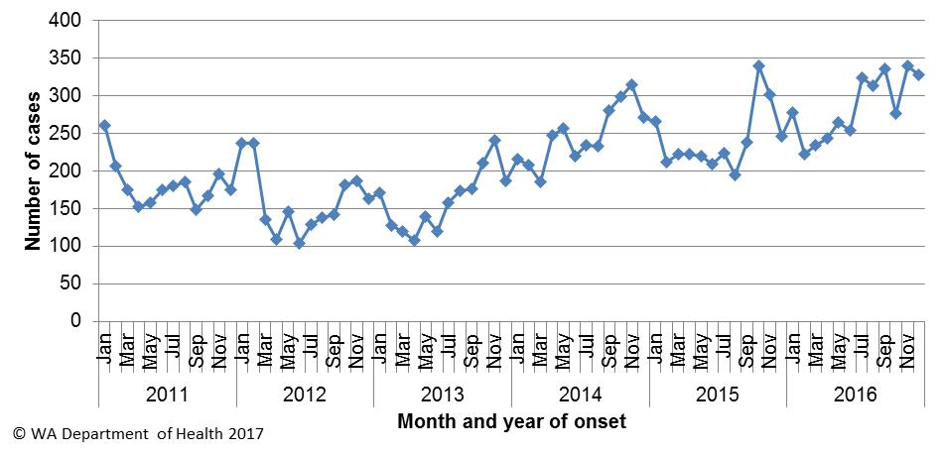

**Figure 1. Number of cases of campylobacteriosis by year and month of onset, WA, 2011 to 2016**

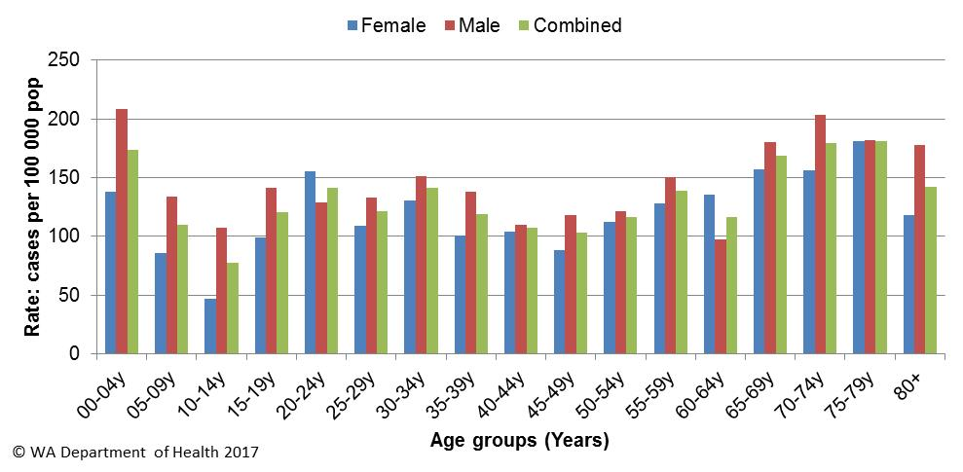

Figure 2: Age-specific notification rates for campylobacteriosis by sex, WA, 2016

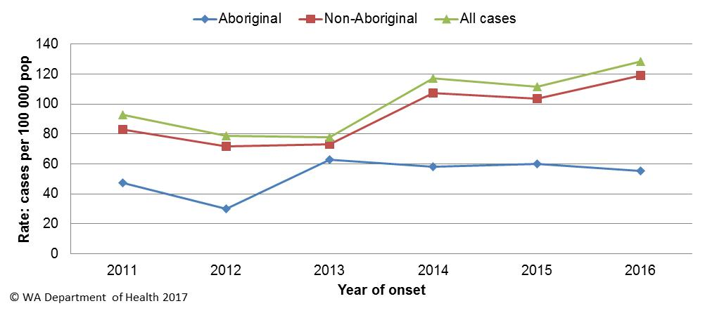

Figure 3. Campylobacteriosis notification rates by Aboriginality, WA, 2011 to 2016

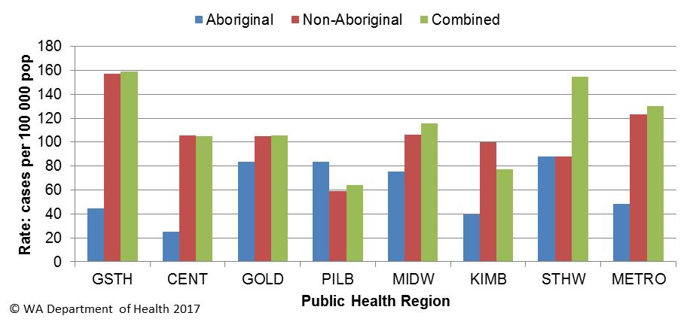

Figure 4. Campylobacteriosis notification rates by region and Aboriginality, WA, 2016

# Salmonellosis

Salmonellosis, which is an infection due to *Salmonella,* was the second most commonly notified enteric infection in WA in 2016, with 1950 cases (Appendix 1). The salmonellosis notification rate for 2016 was 73 cases per 100 000 population which is 36% higher than the previous five year average (54 cases per 100 000 population). The number of salmonellosis notifications was generally highest in the summer months but peaked in March 2016 (Figure 5).

The notification rate for females was slightly higher than for males (77 and 69 per 100 000 population, respectively). As in previous years, the <1- 4 year age group had the highest notification rate (225 per 100 000 population) (Figure 6). The age group 5-9 years, had the next highest notification rates (83 per 100 000 population).

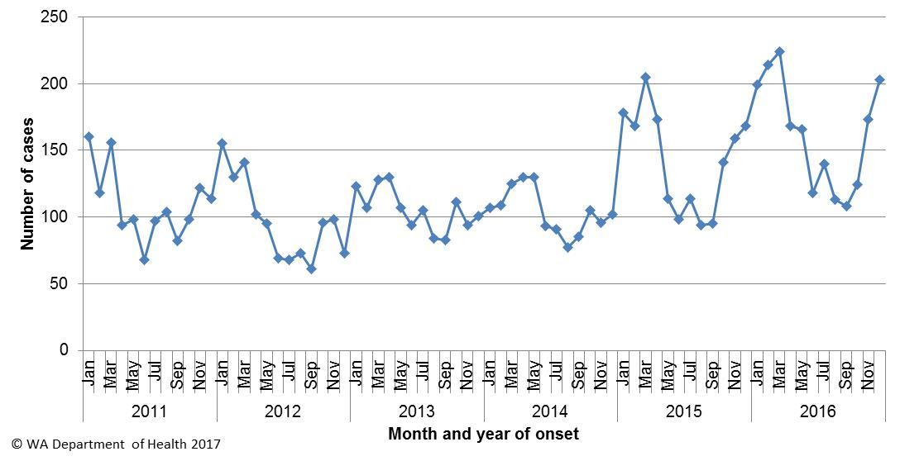

Figure 5. Number of cases of salmonellosis by year and month of onset, WA, 2011 to 2016

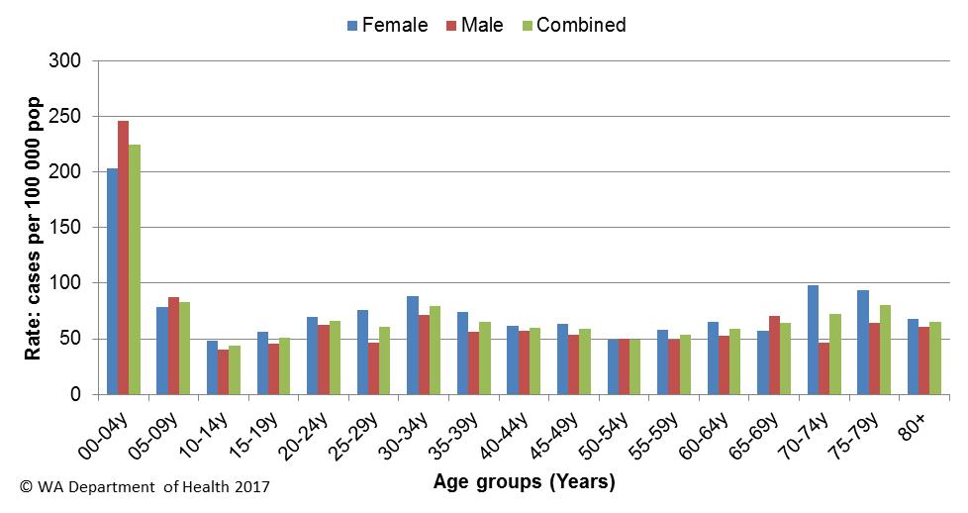

Figure 6. Age-specific notification rates for salmonellosis by sex, WA, 2016

The overall salmonellosis notification rate for Aboriginal people was 91 cases per 100 000 population, which was 1.3 times the notification rate for non-Aboriginal people at 69 cases per 100 000 population.

The KIMB region had the highest notification rate in 2016 (183 per 100 000 population) which was 3.7 times the rate for the CENT region, which had the lowest notification rate at 49 cases per 100 000 population. In the KIMB region, rates were higher for both Aboriginal and non-Aboriginal people when compared with other regions (Figure 7). Of those salmonellosis cases with known place of acquisition (1470/1950: 75%), most (66%) people acquired their illness in WA with 33% of people acquiring their illness overseas. Indonesia was the most common (63%) country of acquisition (Figure 8).

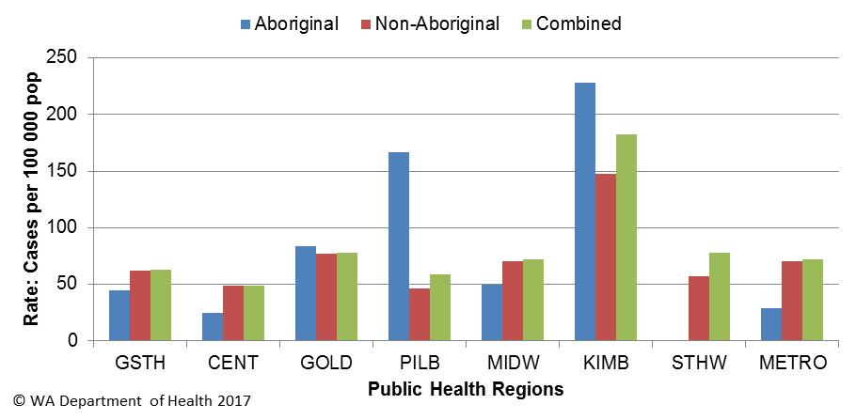

Figure 7. Salmonellosis notification rates by region and Aboriginality, WA, 2016

The most commonly notified *Salmonella* serotype in WA in 2016 was *S.* Typhimurium (STM), with 815 notifications (Table 1), which was 29% higher than 2015 and two fold higher than the mean of the previous five years. There were 16 foodborne outbreaks caused by STM (Section 5.1) with 10 due to STM with PFGE type 0001. There were 52 confirmed cases of STM PFGE1 associated with these 10 outbreaks. In 2016, there were an additional 360 community (sporadic) cases of STM PFGE1 that could not be linked to a point-sourced outbreaks. Raw/runny egg consumption was the main hypothesis for the cause of illness in these community cases (see section 5.3). In 2016, MLVA typing replaced PFGE typing. The most common MLVA type in 2016 was 03-17-09-12-523 (n=78) which is a subtype of STM PFGE type 43. This type was the cause of two outbreaks (See Table 2).

The second most commonly notified serotype was *S*. Enteritidis with 238 notifications which was the same as the mean of the previous five years. In 2016, 87% (208/238) of cases with *S*. Enteritidis infection travelled overseas during their incubation period and of these cases, 62% (n=148) had travelled to Indonesia. There were 28 (12%) cases of *S*. Enteritidis that appeared to be locally acquired, including 13 cases that were part of an outbreak on a cruise ship (Section 5). Interviews of the remaining cases did not identify a common source.

Table 1. Number and proportion of the top 10 *Salmonella* serotypes notified in WA, 2016, with comparison to the 5-year average



*Percentage of total *Salmonella* cases notified in 2016

‡Ratio of the number of reported cases in 2016 compared to the five year mean of 2011-2015.

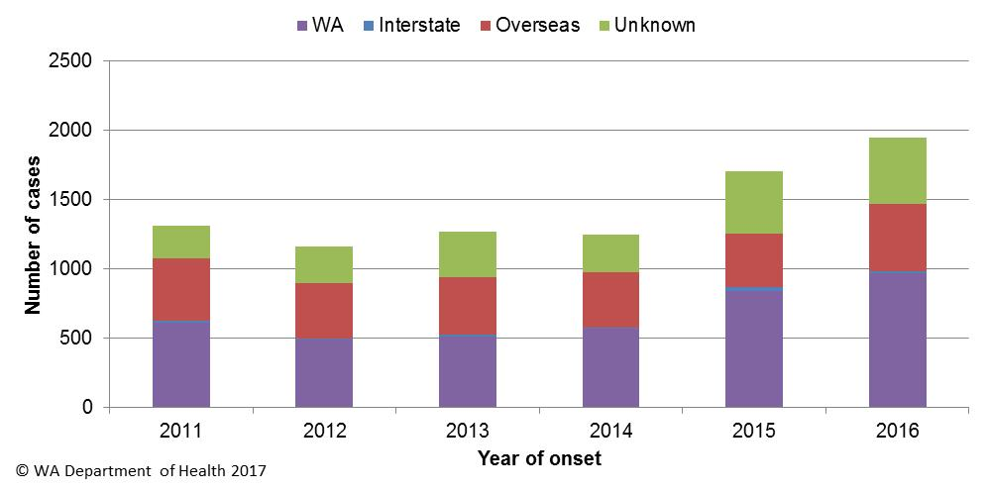

Figure 8. Salmonellosis cases by place of acquisition, by year of onset, 2011 to 2016

# Cryptosporidiosis

There were 245 cryptosporidiosis cases notified in 2016, which was the third most common notifiable enteric disease. The notification rate (9.2 cases per 100 000 population) was 27% less than the mean of the previous five years (12.0 cases per 100 000 population) (Appendix 1). In each of the years from 2011 to 2016 cryptosporidiosis case numbers were higher in the late summer through to autumn.

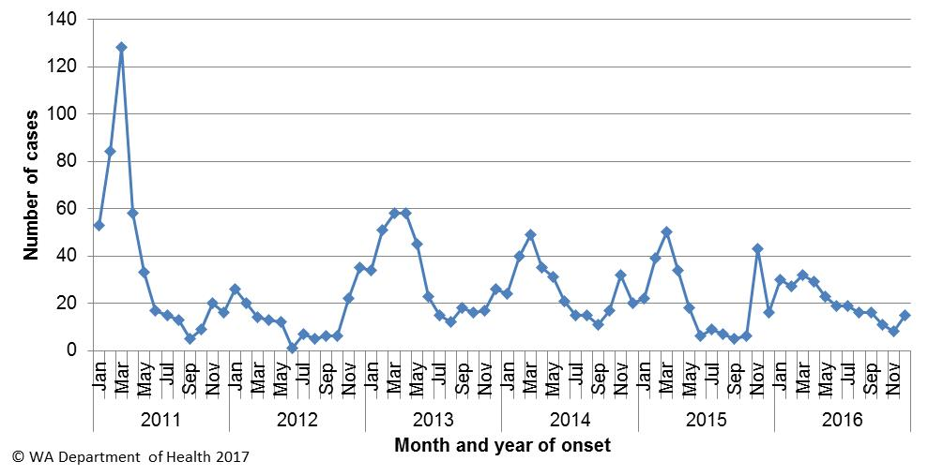

Figure 9. Number of cases of cryptosporidiosis by year and month of onset, WA, 2011 to 2016

The cryptosporidiosis notification rate was similar in females and males in 2016 (8.6 and 9.2 per 100 000 population, respectively). The <1- 4 years age group had the highest notification rate (51 per 100 000 population), and accounted for 38% of all cryptosporidiosis notifications (Figure 10). The overall notification rate for the Aboriginal population was 5.7 times the rate for the non-Aboriginal population (44 and 7.7 cases per 100 000 population, respectively). The KIMB region had the highest notification rate (47 cases per 100 000 population), and the GSTH region the lowest notification rate (5 cases per 100 000 population) (Figure 11). Of those cryptosporidiosis cases with known place of acquisition, most (79%) people acquired their illness in WA, with 19% of people acquiring their illness overseas.

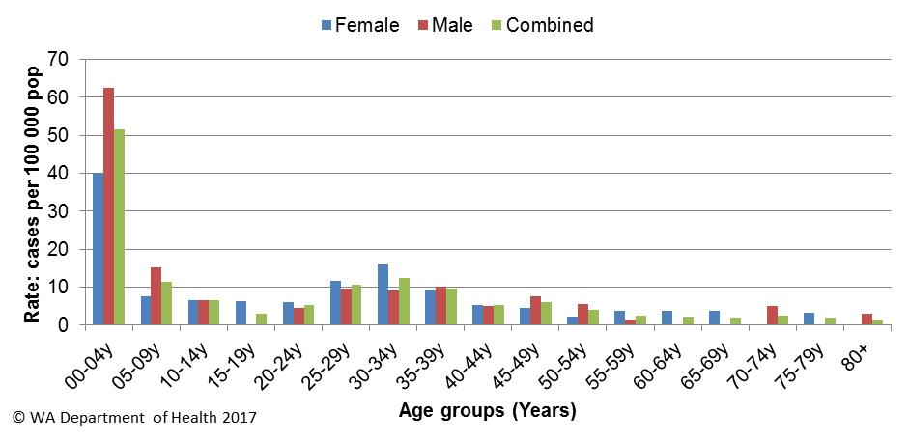

Figure 10. Age-specific notification rates for cryptosporidiosis by sex, WA, 2016

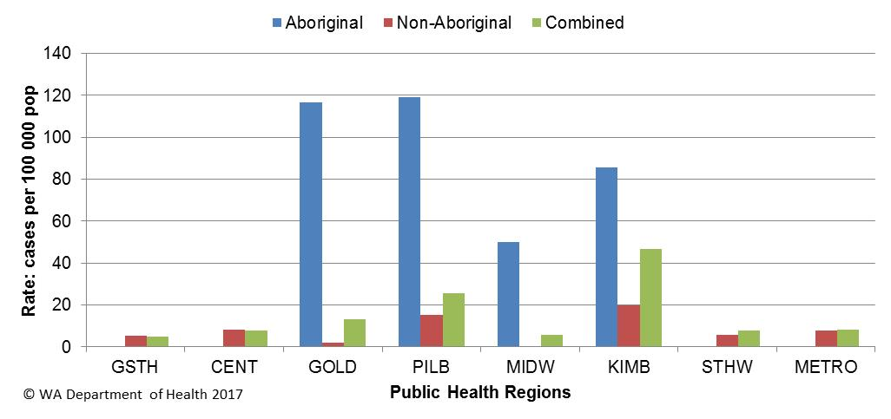

Figure 11. Cryptosporidiosis notification rates by region and Aboriginality, WA, 2016

# Rotavirus infection

There were 180 cases of rotavirus infection in WA in 2016 (6.8 per 100 000 population), making rotavirus the fourth most commonly notified enteric infection. The notification rate in 2016 was 58% lower than the previous four year average of 16.1 cases per 100 000 population (Appendix 1). Historically, rotavirus notifications typically peak in the winter months (Figure 12) but in 2016 rotavirus notifications peaked in March.

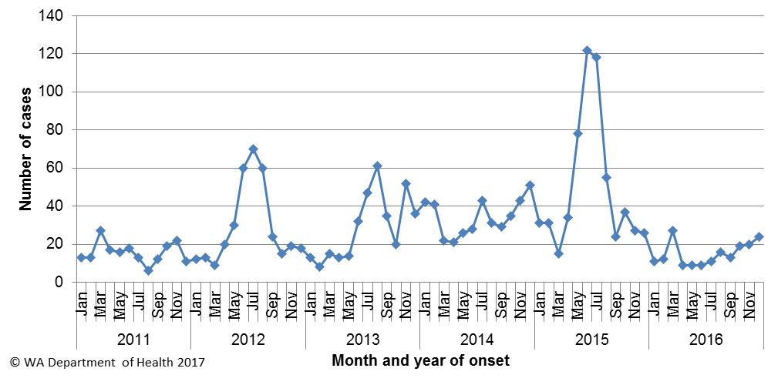

Figure 12 Number of cases of rotavirus infection by year and month of onset, WA, 2011 to 2016

As in previous years, the age group with the highest rotavirus notification rate in 2016 was the <1- 4 years group (67 cases per 100 000 population), the age cohort for which vaccination was available, followed by the oldest age group, the 80+ years group (7 cases per 100 000 population) (Figure 13). The overall notification rate was similar for females and males (5.8 and 7.7 per 100 000 population, respectively).

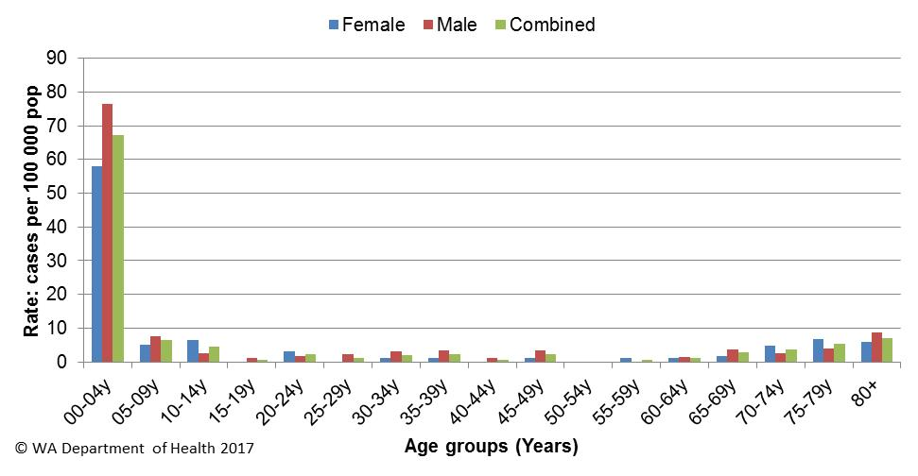

Figure 13. Age-specific notification rates for rotavirus by sex, WA, 2016

The regions with the highest rotavirus notification rates in 2016 were the GOLD, METRO and MIDW regions (12, 7 and 7 cases per 100 000 population, respectively) (Figure 14). Overall, notification rates were 2.7 times higher for Aboriginal than for non-Aboriginal people (16 and 6 per 100 000 population, respectively). Of those rotavirus cases with known place of acquisition, most (91%) people acquired their illness in WA with 9% of people acquiring their illness overseas. There were two person-to-person outbreaks due to rotavirus both in residential care facilities (see Table 3).

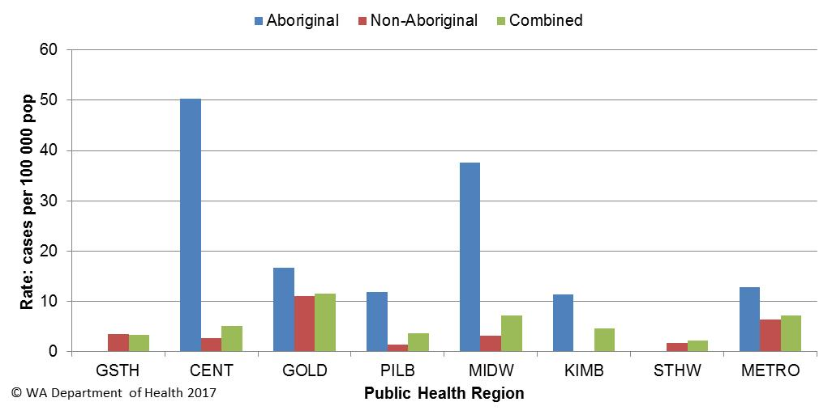

Figure 14. Rotavirus notification rates by region and Aboriginality, WA, 2016

# Shigellosis infection

There were 93 cases of culture positive shigellosis notified in 2016, with a notification rate of 3.5 per 100 000 population, 17% higher than the previous five year average (Appendix 1). The number of notifications was highest in February, July and December of 2016 (Figure 15).

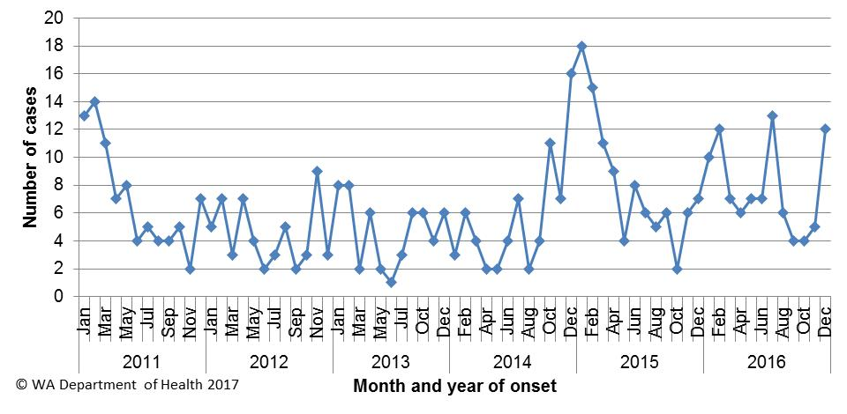

Figure 15. Number of cases of shigellosis by year and month of onset, WA, 2011 to 2016

The shigellosis notification rate was similar for females and males in 2016 (3.9 and 3.5 per 100 000 population, respectively). The <1 to 4 years was the age group with the highest rate of infection with 8 cases per 100 000 population (Figure 16). The population health region with the highest notification rates was the KIMB (16 cases per 100 000 population) (Figure 17).

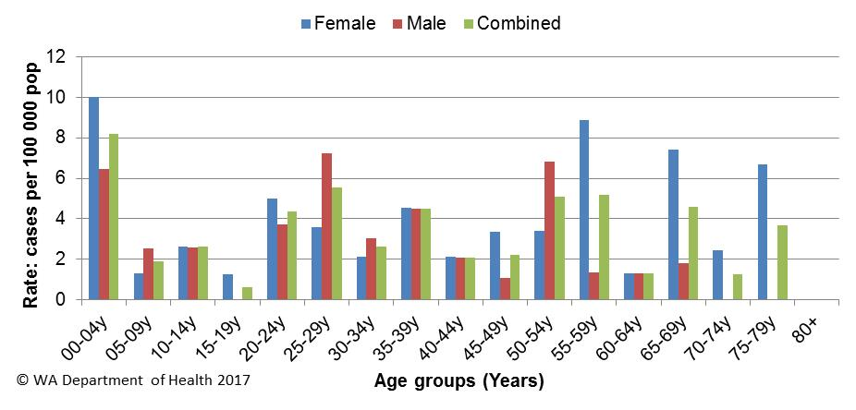

Figure 16. Age-specific notification rates for shigellosis by sex, WA, 2016

In 2016, the notification rate was nine times higher for the Aboriginal population as compared to the non-Aboriginal population (26 and 3 per 100 000 population, respectively).

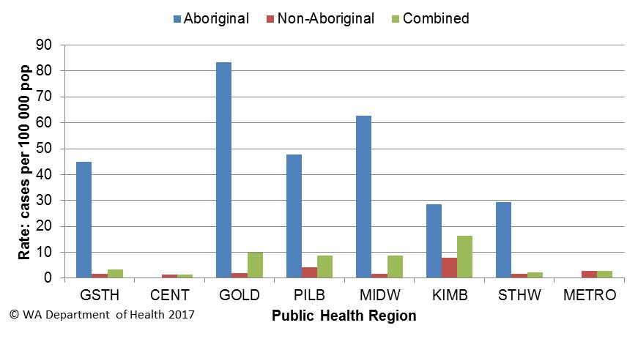

Figure 17. Shigellosis notification rates by region and Aboriginality, WA, 2016

Of the shigellosis cases with known place of acquisition (65/93; 70%), 51% were acquired in WA and 49% were acquired overseas (Figure 18). *Shigella sonnei* was the most common species (n=76, 84%), with *S. sonnei* biotypes A and G equally represented (41% each, 18% biotype unknown). *S. flexneri* was the second most common species (n=11,12%), and there were 4 cases of *S. boydii.*

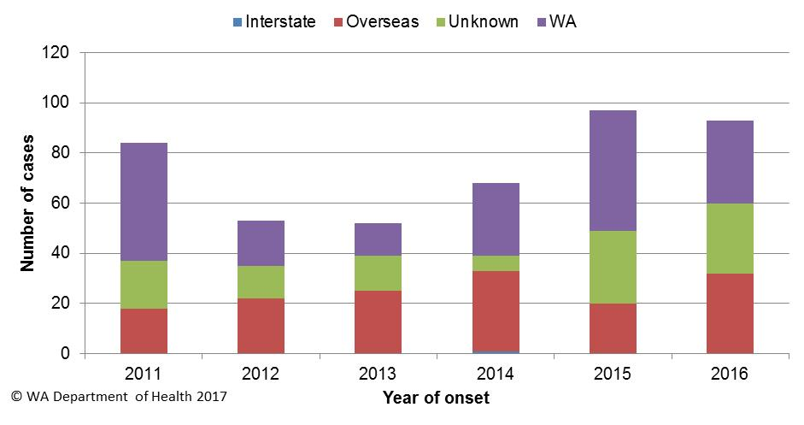

Figure 18. Shigellosis cases by place of acquisition and year of onset, 2011 to 2016

# Hepatitis A

There were 17 cases of hepatitis A notified in 2016 with a rate of 0.6 case per 100 000 population, which is a 7% decrease from the mean rate of the previous five years (Appendix 1).

The age range for the 2016 cases was 1 to 62 years and a median age of 29 years, with 12 male (71%) and 5 female (29%) notifications. Most (10, 59%) notifications in 2016 were acquired overseas (Figure 19) in 9 different countries.

There were five locally acquired cases including:

* 29 yo male with onset in December who was a possible secondary case to a known case who had travelled overseas.
* 62 yo male with onset in April who had consumed frozen berries and who had the same genetic sequence as the national frozen berry outbreak (NFB).
* 1 yo male, 2 yo female and 42 yo male with onsets in January in the same household that consumed frozen berries and who had the same genetic sequence as the NFB.

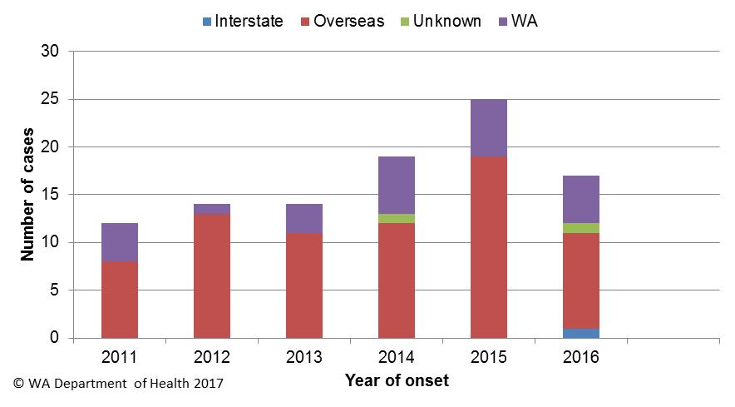

Figure 19. Place of acquisition for hepatitis A cases, 2011 to 2016

# Shiga toxin producing *E. coli*

There were 34 cases of STEC reported in 2016 with a rate of 1.3 cases per 100,000 population which was 12.6 fold higher than the five year average. The majority (n=23) of cases were notified by one pathology laboratory, which started using a faecal PCR screening test for bloody diarrhoea specimens in January 2016. Another laboratory also introduced a PCR test for STEC on request in July 2016, and this laboratory reported nine cases. Of the 34 cases, 29 (85%) had an acute illness prior to testing. Culture was performed on specimens from 26 cases and isolates were obtained from 15 (58%) specimens. Serotypes included O157 (n=6), O111 (n=2), O12 (n=1), O26 (n=1) and five isolates were not able to be serotyped. Of the 34 cases, 18 (53%) were female and 16 (47%) were male with a median age of 25.5 years (range 1-87 years). While most (85%) had acquired their infection in WA, two cases had travelled to Indonesia, one case had travelled to Papua New Guinea and one case was in NSW during their incubation period. Of the cases acquiring their illness in Australia, 16 (53%) had visited or lived in a rural area and eight had contact with farm animals.

# Typhoid and paratyphoid fever

In 2016, there were 12 reported cases of typhoid fever (caused by *Salmonella* Typhi) with a rate of 0.45 cases per 100,000 population, which is similar to the mean rate of the previous five years (Appendix 1). All cases had recently travelled overseas prior to illness and countries included India (n=6), Bangladesh (n=2), Indonesia (n=2), Pakistan (n=1) and Myanmar (n=1). Twelve cases of paratyphoid fever were notified in 2016 with a rate of 0.45 cases per 100,000 population, which is similar to the mean rate of the previous five years (Appendix 1). All paratyphoid fever cases were *S*. ParatyphiA and had overseas acquisition and countries included India (n=9), Indonesia (n=1) and Bangladesh (n=2).

# Listeriosis

There were six cases of *Listeria monocytogenes* infection notified in 2016 with a rate of 0.23 cases per 100,000 population, which is similar to the mean rate of the previous five years (Appendix 1). Notifications comprised two perinatal and four non-pregnancy related cases (Figure 20). One non-pregnancy case did not have any immunocompromising illnesses, while the other three non-pregnancy cases reported regular use of immunosuppressive medications. Cases ranged in age from <1 to 86 years, with four female and two male cases.

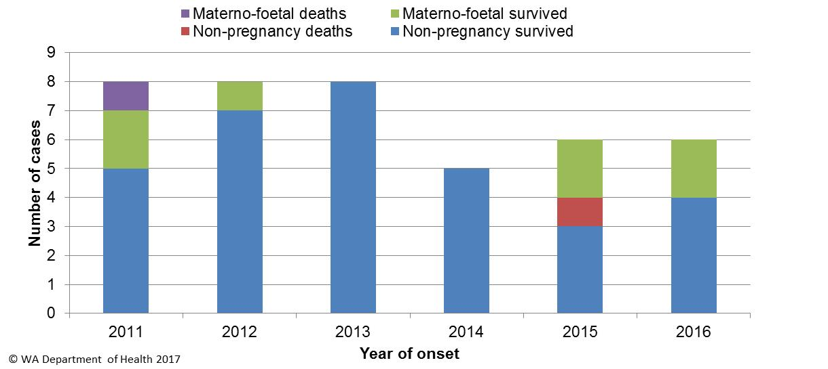

Figure 20. Notifications of listeriosis showing non-pregnancy related infections and deaths, and materno-foetal infections and deaths, WA, 2011 to 2016.

# *Vibrio parahaemolyticus* infection

There were 24 cases of *Vibrio parahaemolyticus* infection in 2016 with a rate of 0.9 cases per 100,000 population which 69% higher than the mean rate of the previous five years (Appendix 1). There were 13 male and 11 female cases, ranging in age from 10-65 years. There were 16 cases reporting travel overseas during their incubation period (to Indonesia n=7, Thailand n=3, Philippines n=2, Vietnam n=2, China n=1, and Singapore n=1) and eight cases acquired their illness in Western Australia. Of the locally acquired cases, two were marine associated wound infections.

# *Yersinia* infection

There were 15 cases of culture positive *Yersinia* *enterocolitica* infection notified in 2016, with a rate of 0.6 cases per 100,000 population which 40% higher than the mean rate of the previous five years (Appendix 1). There were 7 female and 8 male cases with ages ranging between <1 and 84 years. Two cases had acquired their infection overseas, 11 cases had acquired their illness in WA and place of acquisition was unknown for two cases. The majority (n=12) of cases were notified by one private pathology laboratory, which uses a faecal PCR screening test with reflex culture.

# Haemolytic Uraemic Syndrome (HUS)

Three cases of HUS were notified in 2016 in children aged 2-3 years with one male and two females. Two cases were from one family. One case presented to hospital with bloody diarrhoea and vomiting and HUS was later diagnosed. The two family cases had a history of diarrhoea and presented at hospital with symptoms consistent with HUS. Faecal specimens of cases were PCR positive for STEC. One case was diagnosed with STEC serotype O26:H- and the case had exposure to sheep on a farm.One family case was diagnosed with STEC serotype O111:H- and an isolate could not be cultured from the other family case. The family cases had consumed homemade fermented sausage but samples of this sausage were PCR negative for STEC.

# Hepatitis E

There were two cases of hepatitis E notified in 2016. Both cases were male, aged 26 and 27, and both acquired their illness in India.

# Cholera and Botulism

There were no cases of cholera or botulism notified in WA in 2016.

# Gastrointestinal disease outbreaks and investigations

# Foodborne and probable foodborne outbreaks

There were 21 foodborne or probable foodborne gastroenteritis outbreaks investigated in WA in 2016 (Table 2). The 21 foodborne outbreaks caused at least 185 cases of gastroenteritis and 29 hospitalisations. Short descriptions of these outbreaks are provided in 2016 quarterly reports. In the previous five years (2011 to 2015) there was an average of 11 (range 9-14) foodborne or probable foodborne outbreaks per year.

**Aetiology**

Of the 21 outbreaks, 16 were due to STM, with 10 outbreaks of STM PFGE 0001 (multiple MLVA types), two outbreaks of PFGE 0039 (2 MLVA types), two outbreaks of PFGE 0043 (1 MLVA type), one outbreak of PFGE 0013 (1 MLVA type) and one outbreak of PFGE 0092 (1 MLVA type). For the remaining five outbreaks, two outbreaks were due to *Clostridium perfringens* and one each due to *Salmonella* Enteritidis Phage Type (PT) 25 var 1, *Campylobacter* species and *Vibrio parahaemolyticus*.

In the previous five years, *Salmonella* species caused most (n=25, 44%) outbreaks, followed by norovirus (n=9, 16%). There were also three outbreaks due to *Clostridium perfringens,* two due to *Campylobacter* species, two due to hepatitis A and one due to *Listeria monocytogenes*. There were 14 outbreaks where the pathogen was unknown.

**Food vehicles**

The investigations of the 21 outbreaks identified food vehicles for 18 outbreaks. Of these, 14 (78%) were associated with eating egg dishes. Egg dishes included chocolate mousse, poached eggs, tiramisu, egg sauces, omelette and deep fried ice cream. The pathogens that caused the 14 egg outbreaks included nine due to STM PFGE 0001 (multiple MLVA types), two due to STM PFGE 0043 (MLVA 03-17-09-12-523), one each due to STM PFGE 0013 (MLVA type 05-15-13-11-490), STM PFGE 0039 (MLVA type 03-13-11-10-523) and STM PFGE 0092 (MLVA 03-24-13-14-523).

In one outbreak on a cruise ship due to *Salmonella* Enteritidis PT 25 var 1, there was a statistical association between illness and banana or berry smoothies or any fish. There were two outbreaks due to *Clostridium perfringens* and illness in one outbreak was associated with curry dishes and the implicated food was unknown in the other outbreak. The outbreak due to *Campylobacter* was mostly likely due to the consumption of chicken liver pate and in the *Vibrio parahaemolyticus* outbreak all cases had eaten raw oysters sourced from the same jurisdiction outside WA.

In the previous five years there were 57 foodborne or probable foodborne outbreaks and food vehicles were identified for 35 (61%) outbreaks. Of these 35 outbreaks, dishes containing eggs were implicated in 11 (31%) outbreaks (all *Salmonella*), multiple foods were implicated in 10 (29%) outbreaks (*Salmonella* n=3, norovirus n=4, unknown n=3), salads were implicated in four outbreaks (norovirus n=3, *Salmonella* n=1), chicken in two outbreaks (*C. perfringens* n=1, possibly toxin mediated n=1) and other meat in four outbreaks (*C. perfringens* n=1, possibly toxin mediated n=3). Single outbreaks were caused by pate (*Campylobacter*) frozen meals (*Listeria*), kava (hepatitis A), duck pancakes (unknown pathogen) and frozen mixed berries (hepatitis A). Of the 22 outbreaks with unknown food vehicles, the aetiological agents included *Salmonella* (n=10), norovirus (n=2), *Clostridium perfringens* (n=2), *Campylobacter* (n=1) and unknown aetiology (n=7).

**Epidemiological investigation and evidence**

The evidence that supported that the 21 investigations of enteric outbreaks were due to foodborne or probable foodborne transmission was obtained using analytical studies only for four outbreaks, analytical and microbiology for one outbreak, microbiology only for four outbreaks and descriptive cases series (DCS) only for 12 outbreaks. The analytical studies involved interviewing those people who were at the meal using a questionnaire on all foods/drinks available. These studies can be used to find a statistical association between a food eaten and illness, and in 2016 an association was found in five outbreaks. Microbiological evidence refers to the implicated food being positive for the same pathogen as the cases. For the outbreaks investigated as a DCS, there was strong circumstantial evidence to support probable foodborne transmission, such as independently visiting a common food business (12 outbreaks).

For the previous five years the evidence used to support that 57 outbreaks were due to foodborne transmission was obtained using analytical studies for 20 (35%) outbreaks and 10 outbreaks found an association between illness and a food. Two of these 20 outbreaks also had microbiological evidence. Two outbreak only had microbiological evidence. There were 34 (60%) outbreaks investigated as DCS. No formal study was carried out for one outbreak.

**Food preparation settings**

The setting where food was prepared for the 21 foodborne outbreaks in 2016 included nine restaurants (caused by *S*. Typhimurium n=7, *Campylobacter* n=1, *Clostridium perfringens* n=1), seven private residences (all *S*. Typhimurium), one outbreak each in an aged care facility (*Clostridium perfringens*), a bakery (*S.* Typhimurium), primary produce (*V. parahaemolyticus*), a cruise ship (*S*. Enteritidis), and a mobile food vendor (*S.* Typhimurium).

In the previous five years, the most common setting where food was prepared among the foodborne outbreaks was restaurants (n=21, 37%), followed by commercial caterers (n=10, 18%), private residence (n=8, 14%), takeaway (n=5, 9%), aged care (n=3, 5%), two outbreaks each for bakery and camp settings and one outbreak each for childcare, school, cruise ship, prison, primary produce and unknown location for food preparation.

**Major factors for contamination of food**

The major contributing factor for case illness for outbreaks in 2016 was ingestion of contaminated raw products (n=16, 76%), where in 13 outbreaks people were thought to have ingested contaminated eggs and in one outbreak each, people were thought to have ingested contaminated oysters, chicken liver pate and banana smoothie/fish. No factors for the contamination of food could be identified for five of the 21 outbreaks in 2016.

The major factors for contamination of food in the 57 outbreaks in the previous five years were person-to-food-to-person transmission / food handler contamination (n=15, 26%). Of these 15 outbreaks, eight were due to norovirus. There were seven outbreaks where the contributing factor was ingestion of contaminated raw products and four of these outbreaks were due to *Salmonella*. Four outbreaks were thought to be caused by cross contamination with raw ingredients and all were due to *Salmonella*. There was two outbreaks thought to be due to inadequate cleaning of equipment (*C. perfringens* and other toxin mediated illness). There were 29 outbreaks with no identified contributing factor.

Table 2 Foodborne and probable foodborne outbreaks, 2016



1Month of outbreak is the month the outbreak was first report or investigated, whichever is earliest

2PT = phage type, PFGE=pulsed field gel electrophoresis

3 D = descriptive, M= microbiological, A=Analytical

# Outbreaks due to non-foodborne transmission or with an unknown mode of transmission

In 2016, there were 163 outbreaks of gastroenteritis investigated that were not classified as foodborne disease outbreaks (Table 3). These outbreaks included 147 outbreaks associated with probable person-to-person transmission and 16 outbreaks were the mode of transmission was unclear or unknown (Figure 21).

**Probable person-to-person outbreaks**

Of the 147 probable person-to-person (PTP) transmission outbreaks, 94 (64%) occurred in RCF, 29 (20%) in child care centres, 15 (11%) in hospitals, three (2%) on cruise ships, two in schools (1%), and one (1%) each at a sporting event, mental health facility and bus tour (Table 3). The causative agent for 92(63%) of the outbreaks was confirmed as norovirus and two (1%) outbreaks were due to rotavirus and one was due to adenovirus (1%). In the remaining 52 (35%) outbreaks the causative agent was unknown, either because a pathogen was not identified during testing, specimens were not collected, or viral testing was not requested. A total of 4214 people were affected by these outbreaks, with 64 hospitalisations and 13 deaths.

The number of PTP outbreaks in 2016 was a 16% increase on the number of outbreaks in 2015 (n=124), and 22% higher than the average of the previous five years (n=114).

**Outbreaks with unknown mode of transmission**

In the remaining 16 outbreaks the likely mode of transmission was unclear or unknown, with 8 (50%) occurring in aged care facilities, three associated with restaurants and one (6%) each at a hospital, private residence, camp ground, cruise ship, and play centre (Table 3). Below are descriptions of these outbreaks according to the site of the outbreak.

* There were seven outbreaks in residential care facilities where the average percentage of cases with diarrhoea was 98% (range 86-100%) and average percentage of cases vomiting was 3% (range 0-14%). These symptoms are not norovirus-like and therefore described as unknown rather than person-to-person. Most of the outbreaks (5/7) had specimens tested which were negative for common bacterial and viral pathogens (including norovirus). No specimens were tested for two outbreaks. For one other outbreak in a residential care facility, there were three ill with two diagnosed with *Campylobacter* but the mode of transmission was not clear.
* There were eight other outbreaks where there was insufficient information to determine the mode of transmission. This included three outbreaks where patrons reported illness after visiting restaurants and one outbreak each associated with a camp, cruise ship, hospital, play centre and private residence.

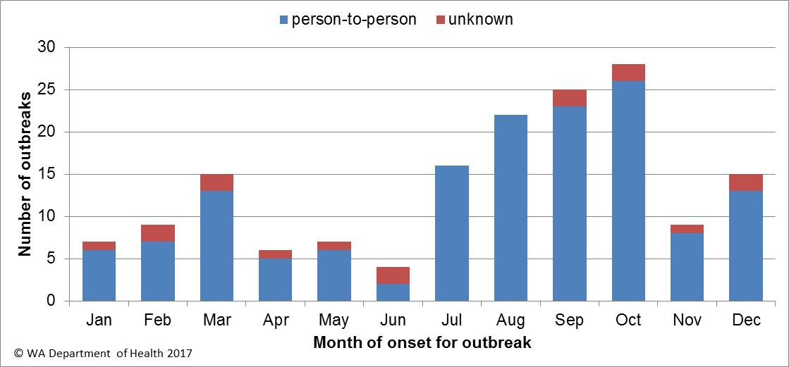

**Figure 21. Number of gastroenteritis outbreaks designated as non-foodborne or with unknown mode of transmission reported in WA, in 2016**

**Table 3. Outbreaks due to non-foodborne transmission or unknown mode of transmission in WA by setting and agent, 2016**



1 Deaths temporally associated with gastroenteritis, but contribution to death not specified

# Cluster investigations

In 2016, there were 11 *Salmonella* clusters, one *Yersinia* and one *Shigella* cluster investigated (see Table 4) which are described in 2016 quarterly reports.

**Significant clusters**

*Salmonella* Typhimurium PFGE 0001

There has been an ongoing community-wide increase in notifications of STM PFGE 0001 (see figure 22) in WA since 2014. Further increases occurred in 2016 with 412 cases of PFGE 0001 infection notified. In 2016, 52 confirmed cases were part of nine point source outbreaks and the implicated foods were raw or undercooked eggs. The remaining 360 cases, comprising 46% males and 54% females, ranged in age from 1 to 96 years (average 29 years), and most (85%) resided in the Perth metropolitan area. In 2016, there were two egg samples and three samples from egg laying chickens from two different egg producers that were positive for PFGE 0001. Eggs from these two egg producers have also been implicated in point source outbreaks. Previous interviews of sporadic cases (not in point source outbreaks) support the hypothesis that the cause of illness was consumption of free range eggs and/or chicken meat at home. From February 2015 to March 2016, non-point source outbreak cases (community cases) were investigated as part of a case-control study of STM PFGE 0001 illness. Final analysis of the case control data showed that eating raw eggs was statistically associated with illness.

This evidence strongly suggests eating raw/runny eggs is the cause of STM PFGE 0001 point source outbreaks in WA and it is very likely the cause of many of the community cases.

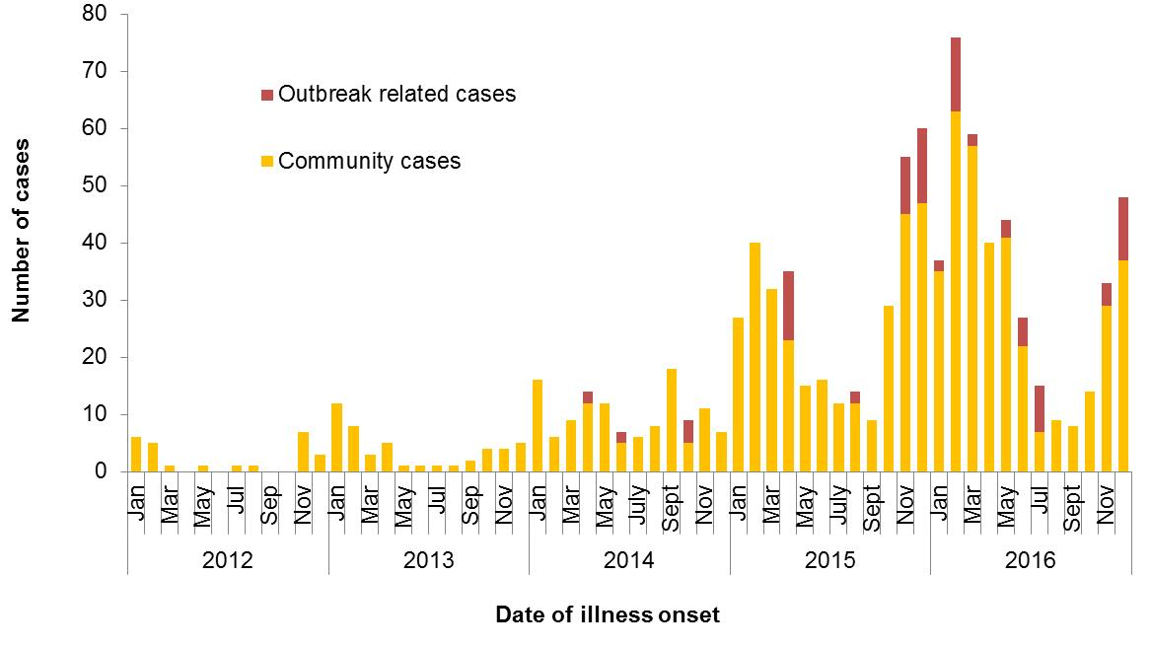 Figure 22. Notifications of *Salmonella* Typhimurium PFGE 0001 in WA

***Salmonella* Typhimurium MLVA 03-17-09-12-523**

Up until September 2016, STM MLVA 03-17-09-12-523 had not been notified in WA since MLVA began in WA in January 2015. There were 78 cases in 2016, starting with a single case in September (Figure 23). Of the 78 cases, seven were part of two point source outbreaks. Both outbreaks are detailed in Table 2. The remaining 71 cases, comprising 42% males and 58% females, ranged in age from 1 to 81 years (median 31 years), and most (82%) resided in the Perth metropolitan area. Hospitalisation data was confirmed for 56 community cased; 36% were hospitalised.

Eggs were implicated in both point source outbreaks of STM MLVA 03-17-09-12-523 in 2016. The egg producer was different in each outbreak. Of the 71 cases not part of these point source outbreaks, 56 were interviewed regarding egg consumption; 77% had consumed eggs in their incubation period, 11% had not, and 13% were unsure. Several different egg brands were reported by cases including the brand of eggs implicated in one of the point source outbreaks. In November 2016, STM MLVA 03-17-09-12-523 was isolated from an environmental sample from an egg farm. No further environmental sampling was conducted in response to this positive sample.

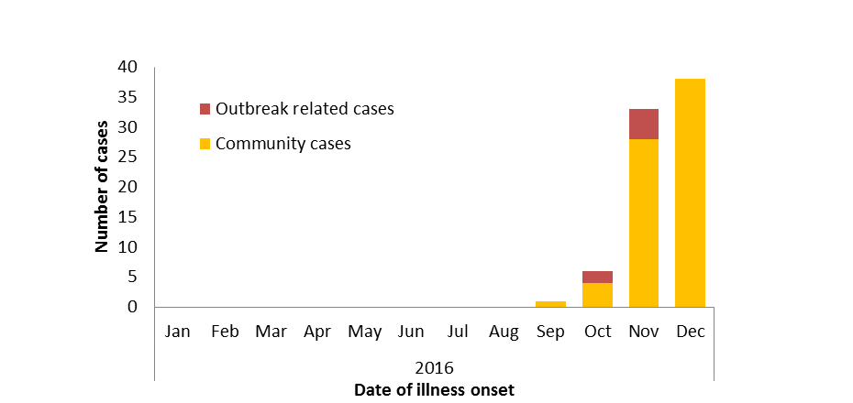

Figure 23. Notifications of *Salmonella* Typhimurium MLVA 03-17-09-12-523 in WA, 2016

Table 4. Cluster investigations in WA by month investigation started, setting and agent, 2016



*PT = phage type, PFGE=pulsed field gel electrophoresis, MLVA=multi-locus variable number tandem repeat analysis

# References

1. Hall G, Kirk MD, Becker N, Gregory JE, Unicomb L, Millard G, et al. Estimating foodborne gastroenteritis, Australia. Emerg Infect Dis 2005;11(8):1257-1264.
2. OzFoodNet Working Group. A health network to enhance the surveillance of foodborne diseases in Australia. Department of Health and Ageing 2013. <http://www.ozfoodnet.gov.au/>.
3. Western Australian Department of Health. A-Z list of case definitions. Western Australian Department of Health 2013. <http://ww2.health.wa.gov.au/Articles/N_R/Notification-of-infectious-diseases-and-related-conditions>.
4. National notifiable disease surveillance system. National case definitions. Department of Health and Ageing 2013. <http://www.health.gov.au/internet/main/publishing.nsf/Content/cda-surveil-nndss-nndssintro.htm>.
5. Western Australian Department of Health. Contact details for regional population / public health units. Western Australian Department of Health 2013. <http://healthywa.wa.gov.au/Articles/A_E/Contact-details-for-population-public-health-units> .

# Appendix 1: Number of notifications, notification rate and ratio of current to historical mean by pathogen/condition, 2011 to 2016, WA

# 

# 1Abbreviations: STEC: Shiga-toxin producing *E. coli*; HUS: Haemolytic Uraemic Syndrome 2Rotavirus was made notifiable in July 2006 3Rate is cases per 100 000 population 4Mean of rates between 20010 and 2014 where applicable. NA: not applicable

© Department of Health 2017

This document can be made available in

alternative formats on request for a person

with a disability