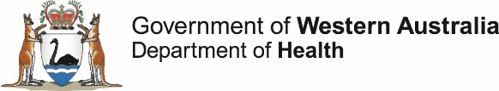

**OzFoodNet Enteric Disease Surveillance Report 2nd Quarter 2019**

This report describes enteric disease surveillance and investigations carried out during the second quarter of 2019 (2Q19) by OzFoodNet WA in conjunction with other Western Australian Department of Health agencies and local governments.

Some of the increase in notifications is likely to be due to the introduction of polymerase chain reaction (PCR) testing of faecal specimens which has greater sensitivity than culture techniques.

**Enhancing foodborne disease surveillance across Australia**

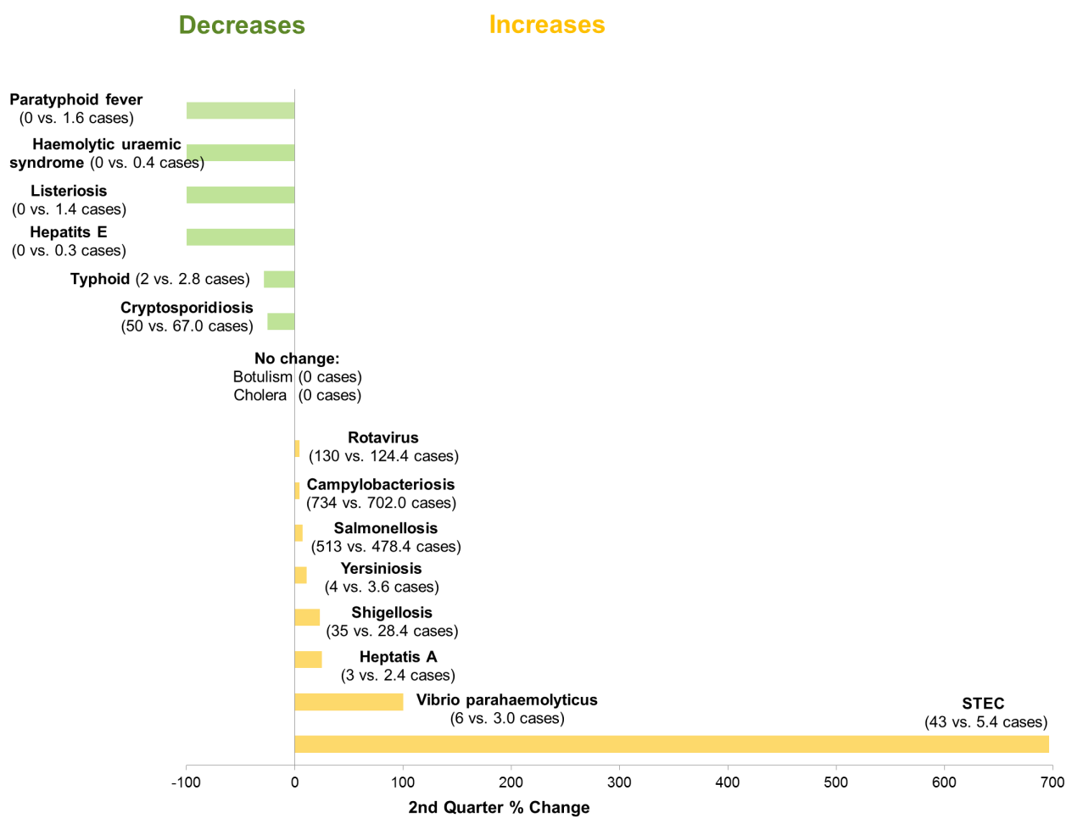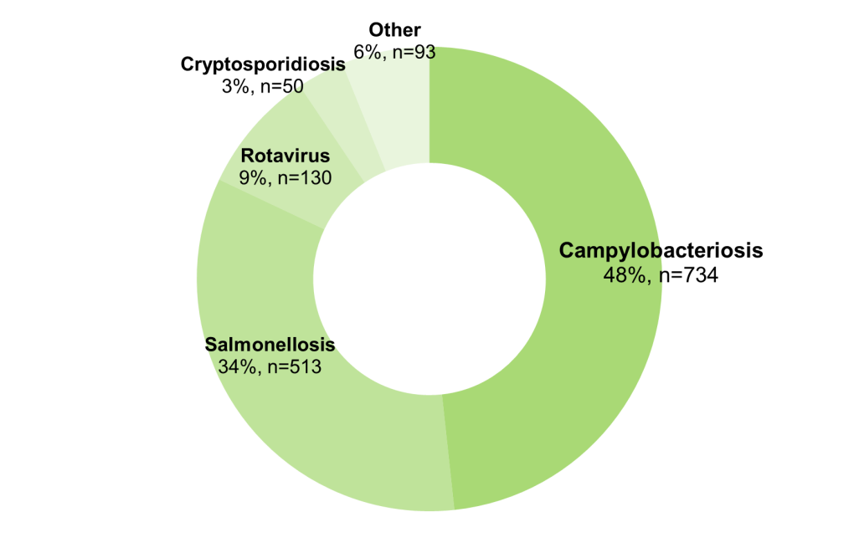

**Appendix 1** Enteric diseases by public health region: <https://ww2.health.wa.gov.au/~/media/Files/Corporate/general%20documents/Infectious%20diseases/Word/OzFoodNet/WA-OzFoodnet-appendix1-2019-Q2.doc>

*Percentage change in the number of notifications in the current quarter compared to the historical 5-year mean for the same quarter. Positive values indicate an increase when compared to the historical 5-year mean of the same quarter. Negative values indicate a decrease when compared to the historical 5-year mean of the same quarter. Percentage change should be interpreted with caution when the number of cases is small.

**Change in enteric disease notifications (%)\***

**Most common enteric disease notifications in Quarter 2 2019**

**Outbreaks in Quarter 2 2019**

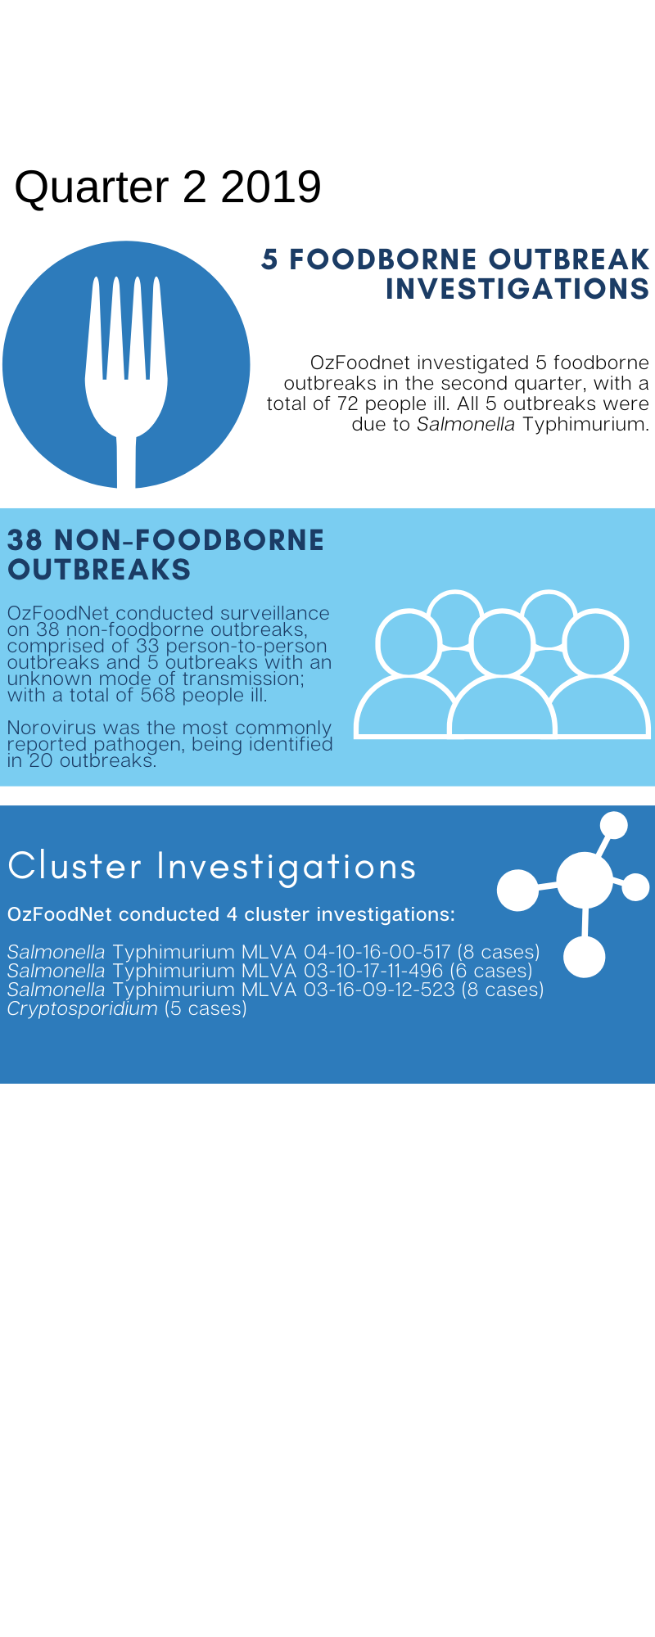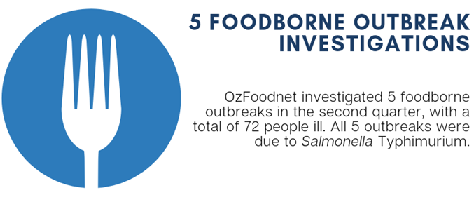

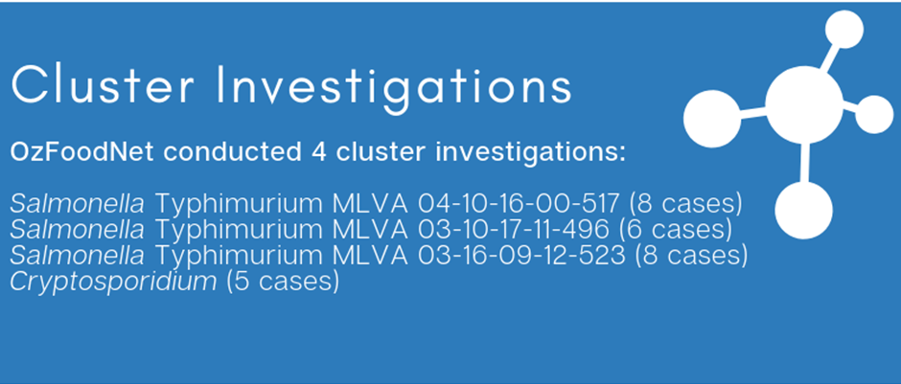

**Appendix 2** Details of foodborne outbreaks investigated in Quarter 2, 2019:

<https://ww2.health.wa.gov.au/~/media/Files/Corporate/general%20documents/Infectious%20diseases/Word/OzFoodNet/WA-OzFoodnet-appendix2-2019-Q2.doc>

**Key trends from Quarter 2 2019**

***Salmonella* Typhimurium (STM) MLVA 03-17-09-12-523**

STM MLVA 03-17-09-12-523 has been under investigation since the type emerged in September 2016. From September 2016 to June 2019 there were 1289 cases notified, including 103 cases in 2Q19. This MLVA type was the single most common MLVA type notified in 2Q19, constituting 39% of STM notifications for the quarter. Of the 103 cases, 6 (6%) were part of two separate point source outbreaks in 2Q19. A paella dish was implicated in one outbreak; the vehicle was unknown in the other outbreak of this MLVA type.Of the remaining 97 cases, most (88%) resided in the Perth metropolitan area. Hospitalisation data were confirmed for 96 community cases; 24% were hospitalised.

Figure: Notifications of *Salmonella* Typhimurium MLVA 03-17-09-12-523 in WA, 2016 to June 2019

Travel associated infection

Overseas acquisition was reported in 305 (20%) of enteric disease notifications in the 2Q19:

* The most commonly reported country of acquisition was Indonesia (59%).

**Shiga toxin producing *E. coli* (STEC)**

Twenty-five out of 43 notifications were culture positive, the most common serotypes were O128 (n=11) and O157 (n=5). No point source outbreaks were identified in 2Q19. Some of the increase is likely due to increased PCR testing by one private laboratory in the fourth quarter 2018.